# Sets Questions:

1. Using the “Sample-Superstore” data set find out:

* Which Customers who gave business in 2021 also purchased in 2022?
* Create a set of all “Eldon” Products that are unprofitable (Note: Use the Formula field to create the Set condition, not a filter)
* Who are my 100 most Profitable Customers AND who also ordered from California?
* Create a Set with 100 or more Customers; What % of Profitability is from these Customers to the Total?

# Filter Questions:

* Which are my top 10 Subcategories by Sales? Which are my Top 10 Sub-categories in Furniture category in the same viz.? [Identify the issue here]
* In the below screenshot, identify what type of filter is being applied with Continuous Month of Order Date on Columns and SUM(Sales) on Rows and Order Date in the Filter Shelf.

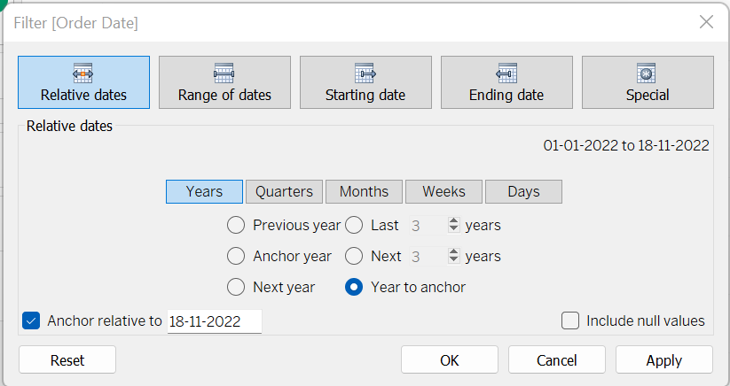

* What is the Total Sale value in Standard Class Ship Mode when the Order Quantity is between 5 to 14?